

**PS 2**



**MID SEMESTER REPORT 2015-2019**

Submitted To: Submitted By:

Dr. Sunil Gupta Puneet Chawla

(Faculty Mentor) 15B00238

CSE 3

Dr. S.K. Gupta (Industry Mentor)



|  |  |
| --- | --- |
| Title of project | Fresher Campus android application |
| Name of student | Puneet Chawla |
| Prescribed date of submission | 25 June 2017 |
| Actual date of submission | 22 June 2017 |

**TABLE OF CONTENT**

|  |  |  |
| --- | --- | --- |
| S.NO. | TOPIC | PAGE NO. |
| 1. | Acknowledgement | 3 |
| 2. | Objective | 4 |
| 3. | Problem Statement | 5 |
| 4. | Company Profile | 6 |
| 5. | Project Methodology | 07-08 |
| 6. | Data Collection/Project Design | 09-13 |
| 7. | Result/Discussion | 14-19 |
| 8. | Conclusions | 20 |



# ACKNOWLEDGEMENT

The satisfaction that accompanies that the successful completion of anytask would be incomplete without the mention of people whose ceaseless cooperation made it possible, whose constant guidance and encouragement crown all efforts with success. I am grateful to my project guide Dr. S.K. Gupta (Director Xcrino Business Solutions) for the guidance, inspiration and constructive suggestions that helpful us in the preparation of this project. I also thank Mr. Lovelesh Singh for providing me all the necessary details and database related to the project. My special thanks to Dr. Sunil Gupta whose guidance and constructive suggestions helped in completion of this project.

This project was handed to me on June 12, 2017 and was completed and delivered to the company on June 22, 2017. Within this span I learned a lot of useful things related to project development on android platform which includes:

* Working of web view with fragments and activities
* Fetching real time database
* Online card view and recycler view generation
* JSON file creation
* User authentication through google
* Opening a PDF file from internet in the application and activity
* Jsoup to separate divisions of the data from a website to render on the application
* Hands on experience on various stages of a project development

My industry mentor was impressed by my work and now I am provided with another project. All thanks to both faculty and industry mentor for believing in me and BML MUNJAL UNIVERSITY for providing such a wonderful training program to learn the actual functioning of an organization.



# OBJECTIVE

The objective of the project was to develop an android application to expand the website “fresherCampus.com” to android platform for the users. The application focus to provide internship and job opportunity to the students. The data for this app is broadly classified under three main categories namely on-campus, off-campus and walk-in. It also provide the users a list of companies that are available for recruitment. Thus creating easy and hassle-free way for the students to search job and internship as per their requirement. It also provides the requirements of the companies for the post available, perks or salary that the companyoffers, website link to know more about the organization, application form to apply, resume preparation and interview tips for the students. It also provides a blog to interact and share knowledge about various aspects related to recruitment and placement of various companies so as to make a clear image of the process for new students.

The entire data for the application along with its notification generation is maintained and administrated by me. The entire project was developed in a span of almost 10 to 15 days which a quiet a learning experience. The website is itself is under development new features and database development is under progress but the application part on which only I was working has been completed before the deadline and is under testing process which will be later available to the public domain on google play store.



# PROBLEM STATEMENT

The task was to create an application on google API-19 to provide a solution for easy and hassle-free to search job and internship related data for the students from various companies in real-time rendering, addition of data, notification generation and simpler UI which provides all the information related to the recruitment process like the name of the company, apply link, post available, website of the company, experience required for the job.

Fresher Campus mobile application:

1. Target Age Group – 20 to 30 years
2. Platform - Android
3. Availability – Play Store
4. Audience – Students
5. Requirement – Real time database
6. Parts of website linked to application
7. Blog Activity
8. Resume creator
9. Simple UI
10. Horizontal Slider and company’s profile attached



# COMPANY PROFILE



Xcrino Business Solution provides expert solutions to their clients. They provides solutions in manpower, training solution, digital marketing, application development, customer support.

Company website- [www.xcrino.com](http://www.xcrino.com/) Email Address- [info@xcrino.com](mailto:info@xcrino.com)

* + As a part of IT solutions they provide testing, designing, web application development, android development, digital marketing.
  + Manpower solutions like accountability, productivity, options and innovation, customer relation and finance, accountability.
  + Marketing solutions such as overseas, institutional and brand marketing.
  + The company also provides training to the students for web development

# PROJECT METHODOLOGY

The approach towards solution to the given problem involved following steps:

1. Designing the solution related to the work flow of the data and user’s interaction with the application

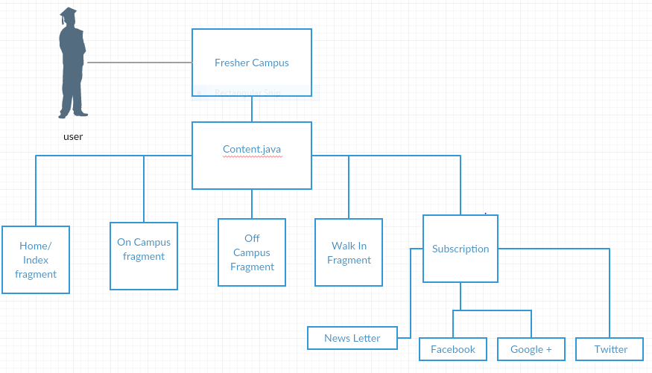

The design for solution involves:

* + On campus activity
  + Off campus activity
  + Walk in activity
  + Subscriptions and communication
  + Home or index fragment
  + Companies profile
  + User login screen

1. Solution 1 –

It involved designing the application on navigation drawer API providing all the points in the design to lead up into a webview and Jsoup file to render the database as soon as it is updated on website to display those changes simultaneously on the application.

The basic idea behind this approach was to lower the cache and smaller space requirement of the application.

Problems with solution 1 were:

* + No data will be available to user without internet
  + Limited to the functionality available in the website
  + Complex UI for the user to understand

1. Solution 2- Approved solution which counters all the problems in solution 1 This solution involves use of
   * Navigation drawer and web view along with
   * Horizontal scroll view
   * Card view
   * Recycler view
   * A separate notification generator and
   * Separate database for the application in json file format
   * Database is automatically updated
   * Provides the previously loaded data to the user without internet connection. It involves user authentication to load pdf files.
   * Blogging activities
   * Simpler UI for the users to interact.



# DATA COLLECTION AND PROJECT DESIGN

1. Data Collection:

The data required to design and develop this project was provided from the freshercampus.com itself for which the app was required to be developed the collected data was then converted to .json file format and was added to an online server to provide real time database rendering to the user along with login for user authentication with google account.

1. Project Design:

Designing the solution related to the work flow of the data and user’s interaction with the application

The design for solution involves:

* + On campus activity
  + Off campus activity
  + Walk in activity
  + Subscriptions and communication
  + Home or index fragment
  + Companies profile
  + User login screen



Detailed Description of design:

Solution 1:

* + Making of Architectural design
  + Designing of web View
  + About Us Activity Design and linking to Navigation Drawer
  + Linking Fragment
  + Action Bar Design
  + Image Slider layout and Design
  + Navigation Bar Design and connectivity
  + Splash Screen
  + Navigation Drawer Design
  + Linking freshercampus.com with web view
  + Connecting each tab of site with button in drawer
  + Web view is added to each fragment
  + Jsoup is added to the project with which each div of web page is separated and added to different fragments of the project
  + Social connectivity and Subscription is added to the application

Solution 2:

* + Redesigning Architectural design
  + Designing new activities
  + Firebase Notification added
  + Activities are added with butterknife.jar
  + New Action Bar Design
  + Image Slider layout
  + Scroll View and Horizontal Scroll View
  + New Splash Screen and new icon designed for the application
  + Navigation Drawer added to the application with glider classpath
  + Card View design and adapter added for 10 scroll buttons
  + Added social media connectivity
  + Recycler View is added to each activity
  + Subscription and gmail app is added for getting feeback from fab button on content.java
  + Pdf viewer is added to activity
  + Title and back button are added to Action Bar of each activity

Creating database using firebase and with UI enhancement, google Authentication for PDF view and unsigned apk generated for testing.

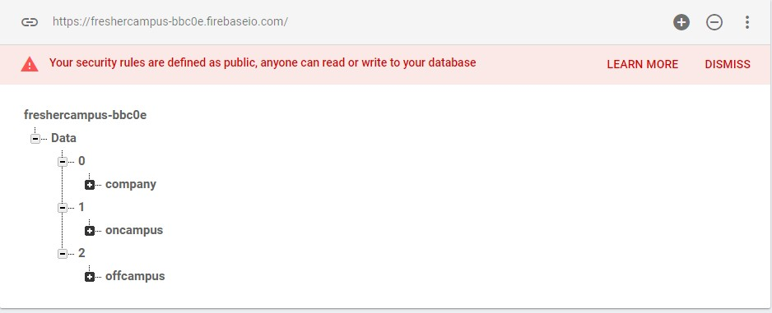

* + Making of Database design
  + Designing of Firebase Recycler Adapter
  + Linking Firebase Database to application
  + Using Database Reference and Firebase classes to render the data in the activities



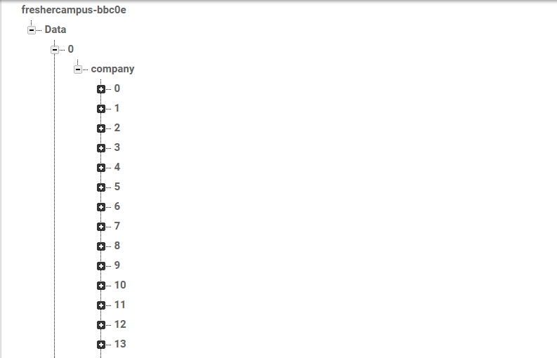

* + Designing card view to add online data to the application which is automatically refreshed
  + Adding Model class to and add its setters and getters
  + Adding progress Dialog to provide easy loading of data
  + Adding companies activity to application
  + Enhancing gilding of navigation bar for easy reference
  + Adding Pdf view to activity to read interview.pdf



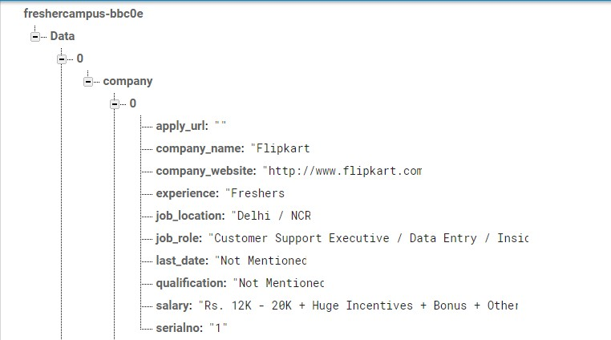

# RESULT



1. The resulting application has following features:
   * Offline availability of data
   * Subscription and feedback
   * Enquiry email option
   * Job description
   * Experience, salary and skills required
   * Both job and internship options available
   * On campus, walk-in and off campus access availability
   * Alert notification
   * Location search (near you)
   * All available companies profile and basic requirement
2. Requirement:
   * Internet connection to refresh the database
   * Android 4.4 and above
3. Screenshots of resulting application:
   * “FC” logo designed

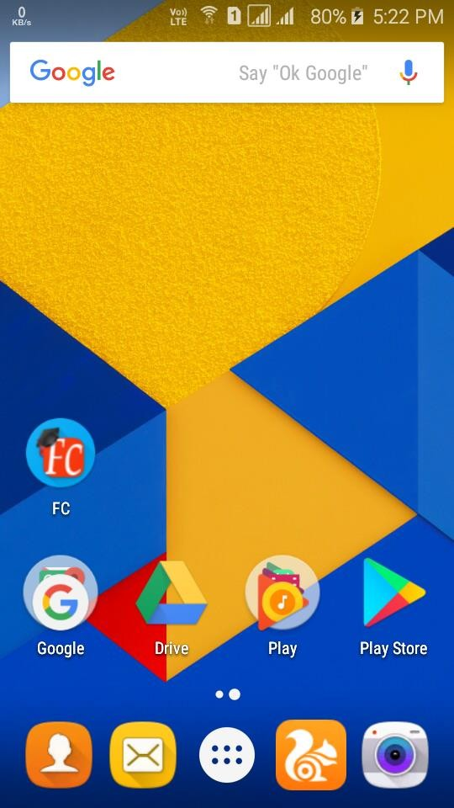

* + Splash Screen

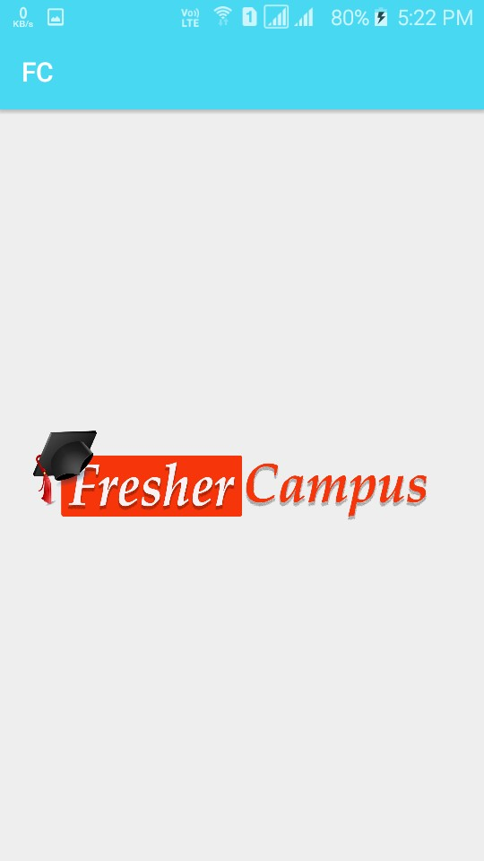

* + One time welcome screen

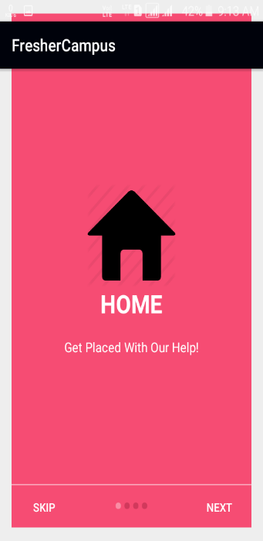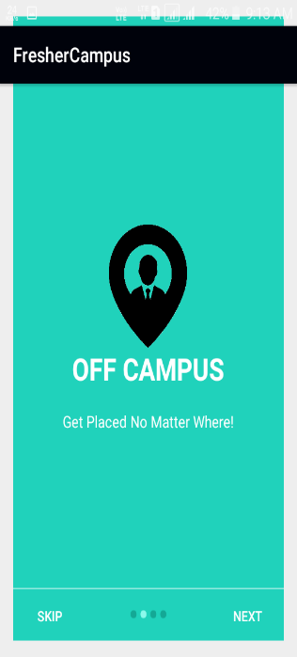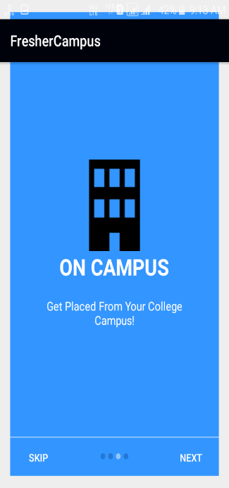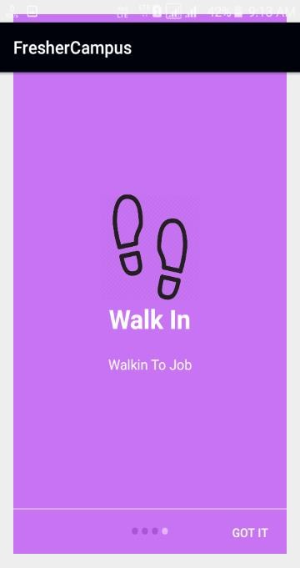

* + Main Activity



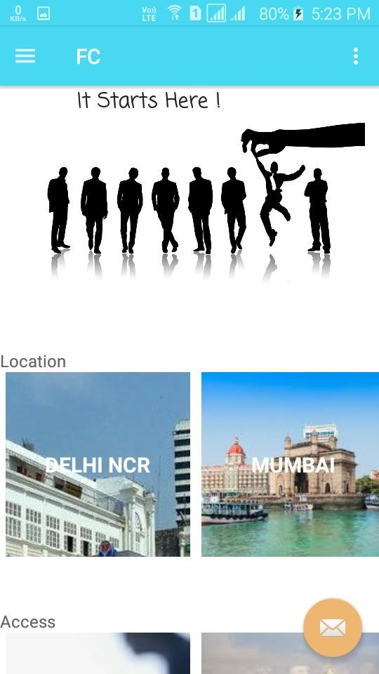 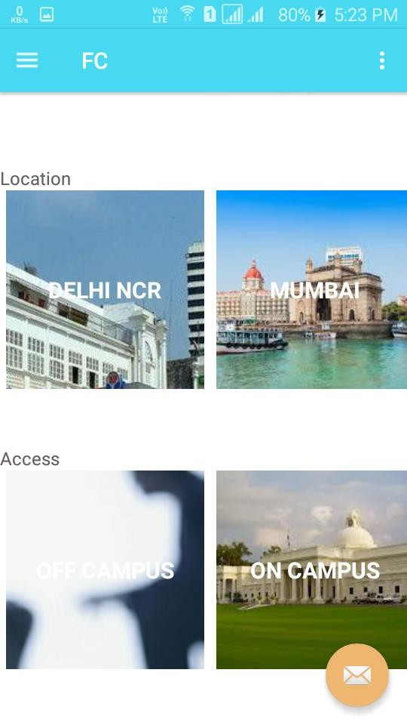

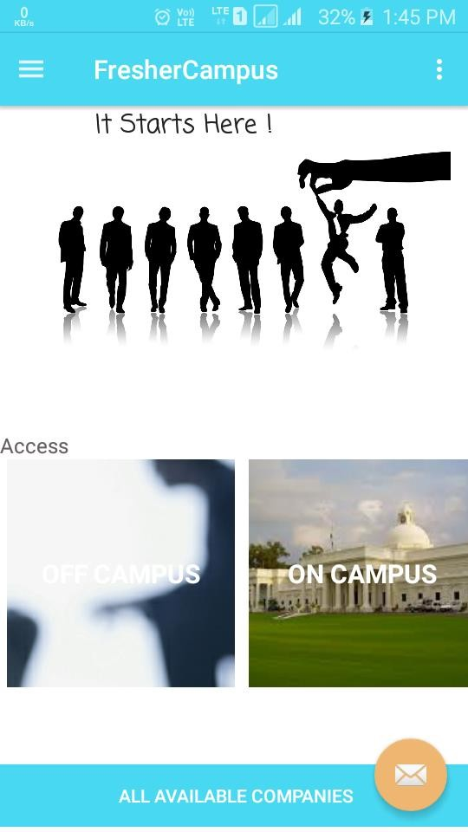

* + Navigation Bar design

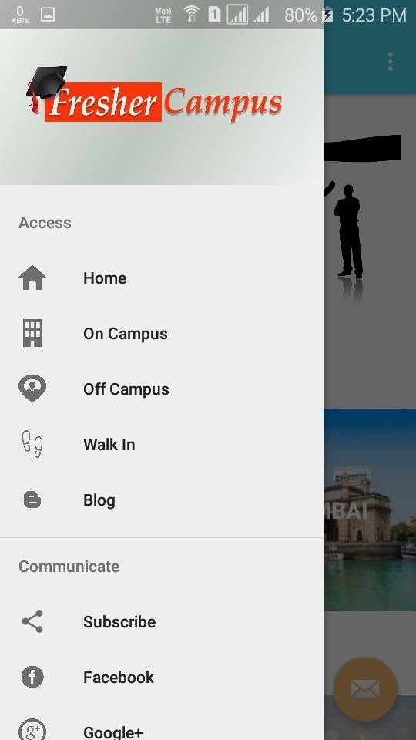

* + Blog Activity

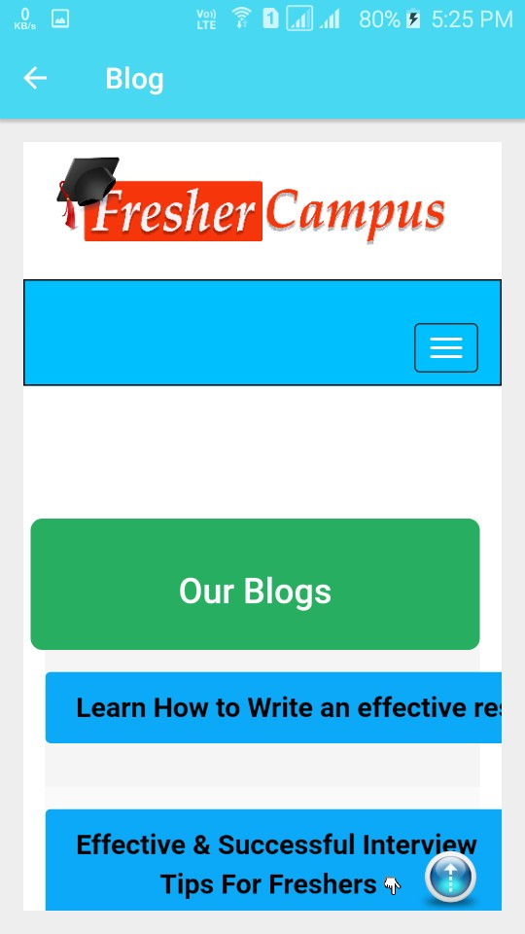

* + Off campus activity

Recycler and card view with real

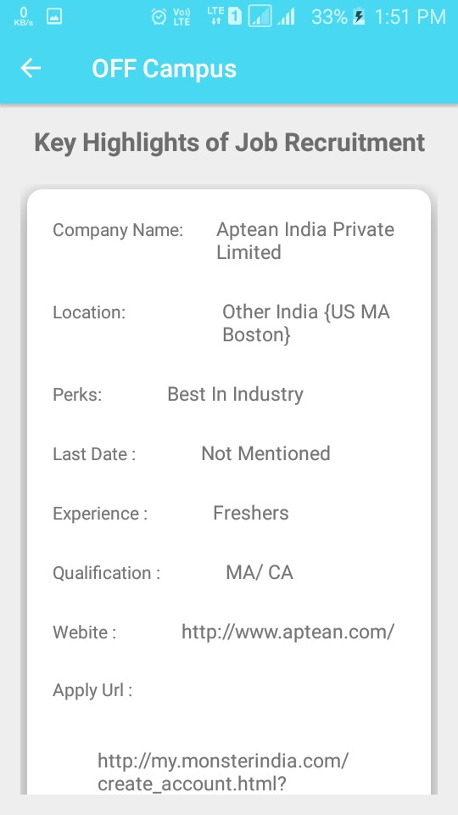

time database

* + Google Authentication

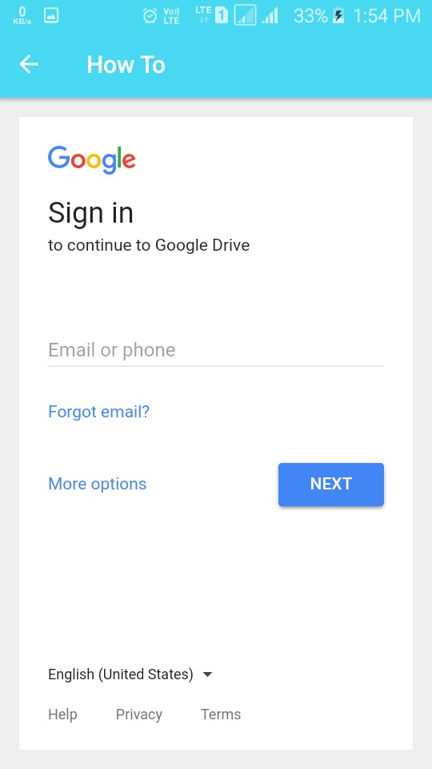



* + Pdf view

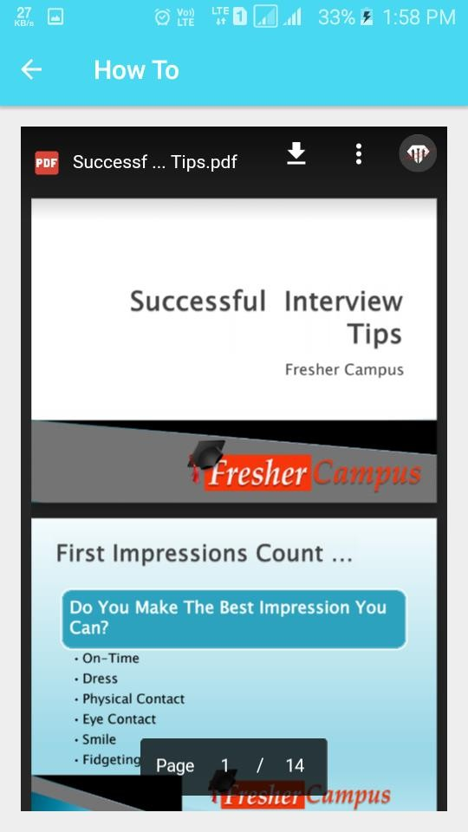



# CONCLUSION

This project was handed to me on June 12, 2017 and was completed and delivered to the company on June 22, 2017. Within this span I learned a lot of useful things related to project development on android platform which includes:

* + Working of webview with fragments and activities
  + Fetching realtime database
  + Online cardview and recyclerview generation
  + JSON file creation
  + User authentication through google
  + Opening a PDF file from internet in the application and activity
  + Jsoup to separate divisions of the data from a website to render on the application
  + Hands on experience on various stages of a project development